Ideation Phase Empathize & Discover

Date | 29 July 2026
Team ID
Project Name | Visualizing Housing Market Trends:An Analysis of Sale Prices and Features using Tableau
Maximum Marks | 4 Marks

Empathy Map Canvas:
An empathy map is a simple visual tool used to understand users' behaviours, needs, and challenges.
It helps the team gain insights into the perspectives of home buyers, sellers, and real estate investors.
For this project, it identifies how users interact with housing market data and pricing information.
Users often face difficulties in understanding complex real estate trends and property features. The empathy mapping process helps uncover users' goals, pain points, and expectations.
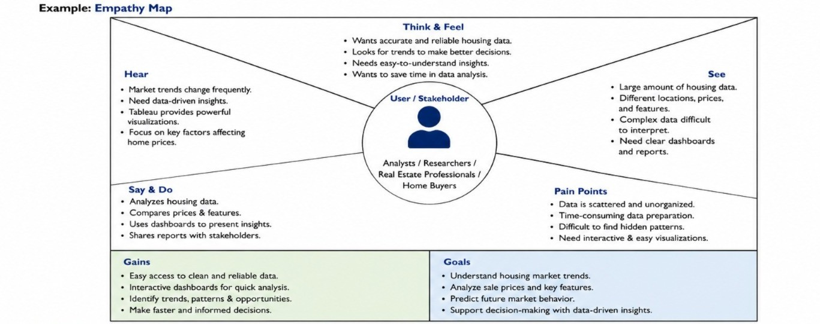
This understanding supports the development of an effective Tableau dashboard for better housing market analysis and decision-making.

Reference: https://www.mural.co/templates/empathy-map-canvas

EMPATHY MAP CANVAS
